

**Data Visualization**

**DIGITAL ASSIGNMENT**

Visualization of Lok Sabha Election (1962-2019)

**FINAL REPORT**

**COURSE CODE: CSE3020 SLOT: E2**

**FACULTY: RAJA M**

**TEAM MEMBERS:**

**Pharos Sophy Samuel T J (20BAI1049)**

**Table of Content**

|  |  |  |
| --- | --- | --- |
| **S No.** | **Title** | **Page No.** |
| **1** | **Abstract** | 3 |
| **2** | **Introduction** | 4 |
| **3** | **Review of Literature** | 5 |
| **4** | **Materials & Methods** | 6 |
| **5** | **Proposed Work** | 7 |
| **6** | **Results & Discussion** | 8 |
| **7** | **Conclusion** | 14 |
| **8** | **Project Code Link** | 15 |
| **9** | **References** | 16 |

# 1.ABSTRACT:

The Lok Sabha elections in India have been a significant event in the country's political history, and analyzing the data from these elections can provide valuable insights into the changing political landscape of the country. This study provides an analysis of the Lok Sabha elections held between 1962 and 2019, using visualizations to explore the trends and patterns in the data.

The study found that the Indian National Congress dominated the Lok Sabha elections from 1962 to 1984, winning a majority of seats in all the elections except for 1977.

The study's use of visualizations provided a powerful tool for exploring the data and highlighting the key trends and patterns. The study's findings underscore the importance of understanding the role of caste and religion in the Lok Sabha elections and the changing political dynamics of the country. Overall, the study provides valuable insights into the political landscape of India and the factors that have influenced the outcomes of the Lok Sabha elections over the years.

# 2.INTRODUCTION:

This study provides a visual analysis of the Lok Sabha elections in India from 1962 to 2019. Using various charts and graphs, the study presents a comprehensive view of the trends and patterns in the electoral outcomes over the nine elections.

The study also analyzed the performance of the major political parties in the Lok Sabha elections. The BJP's rise to power in the 1990s and its dominance in the 2014 and 2019 elections are clearly visible in the visualizations. The study also highlights the electoral performance of the regional parties, which played a significant role in shaping the political landscape of India.

This study also provides a visual analysis of the Tamil Nadu assembly elections held between 1962 and 2019. Using various charts and graphs, the study presents a comprehensive view of the trends and patterns in the electoral outcomes over the nine elections. The study also analyzed the performance of the major political parties in the Tamil Nadu assembly elections. The charts on seats won and vote share clearly depict the dominance of the Dravidian parties over other parties like the Congress and the BJP.

Overall, the visual analysis of the Lok Sabha elections and Tamil Nadu assembly elections provides valuable insights into the changing political dynamics in India. The charts and graphs offer a comprehensive view of the trends and patterns in the electoral outcomes over the years, highlighting the importance of understanding the various factors that influence the outcomes of the Lok Sabha elections.

# 3.REVIEW OF LITERATURE:

1. “Trend Analysis and Predictive Modeling Using Machine Learning Models on Indian Election Historical Dataset”, the authors used various modelling techniques like Gaussian Naive Bayes, Extra Tree Classifier, K-Nearest Neighbors Classifier (KNN), Logistic Regression and Decision Tree Classifier. ,results of five model used for study were evaluated and compared

2. “Prediction of Indian election using sentiment analysis on, IEEE Xplore, Available at : <https://ieeexplore.ieee.org/document/7840818>

3. “Predictive Analysis of Indian Elections using Machine Learning Techniques”, International Journal of Computer Science and Mobile Computing, ISSN No. 2320-088X, Volume 8, Issue 4, April 2019, <http://www.ijcsmc.com/docs/papers/April2019/V8I4201911.pdf>

4. K. Myilvahanan, Y. P, S. Pasha, M. Ismail and V. Tharun, "A Study on Election Prediction using Machine Learning Techniques," 2023 Third International Conference on Artificial Intelligence and Smart Energy (ICAIS), Coimbatore, India, 2023, This paper works on demonstrating and building new characteristics that helps in showing that a machine learning supervised learning technique which uses the most recent Indian electoral datum for forecasting the overall outcomes of national elections as well as many local results.

5. “Analysis and Prediction over Indian Election Dataset”, 2018 is a sentiment analysis of election details is done in this report. Machine based lexicon approach to finding emotions and twits

6. “Predictive Analysis of Indian Elections using Machine Learning Techniques”, International Journal of Computer Science and Mobile Computing, ISSN No. 2320-088X, Volume 8, Issue 4, April 2019,

7. This blog helped in analysing the features of the dataset and the method of <https://analyticsindiamag.com/6-datasets-to-visualize-lok-sabha-election-by-numbers/>

# 4.MATERIALS AND METHODS:

## 4.1INFORMATION ABOUT MODELS:

## Various visualization was done in this project like representation of voters and elections, count of constituency increase over the years. Scatter plot was used with electors and votes keeping years as hue. A distplot was used which represented a bimodal graph between electors and density. A joint plot which normally is used to demonstrate the complete view on the count of votes with respect to voters.

## There are machine learning and deep learning models in the project. There is no need to modulate the dataset to predict anything since election prediction with previous year representation is useless since it works by people’s sentiment and the propaganda done by individual parties

## 4.2DATASET

This dataset contains information about the Lok Sabha election and Tamil Nadu assembly elections Tamil Nadu assembly elections between 1962 and 2019.

Based on various parameters the data has been visualized for the Lok Sabha elections and Tamil Nadu assembly elections. The dataset contains 8047 x 42 (rows x columns) .

The features in the dataset include:

* + - Categorical Features:
      * Pc_name
      * type
      * state
      * candidate name
      * Generation
    - Numerical Features:
      * number
      * electors
      * voters
      * turnout
      * margin
      * margin %
      * year

# 5.PROPOSED WORK

## 5.1. NOVELTY:

Our project could involve creating interactive data visualizations that allow users to explore the historical data on the Lok Sabha or Tamil Nadu assembly elections in a more engaging and interactive way and predicting the votes. This could involve creating interactive dashboards or web applications that allow users to visualize the data in different ways and filter the data based on different variables, such as time period, political party, and voter demographics.

Our novel approach to data visualization on suicide data refers to the use of geospatial visualization which enables users to explore data on a geographic map, providing a unique perspective on the distribution and patterns of suicide across different regions.

# 6.RESULTS AND DISCUSSIONS

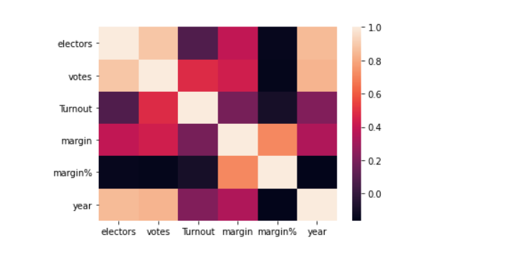

We can see electors and votes are highly correlated with each other and year with (electors and votes are highly coorelated)

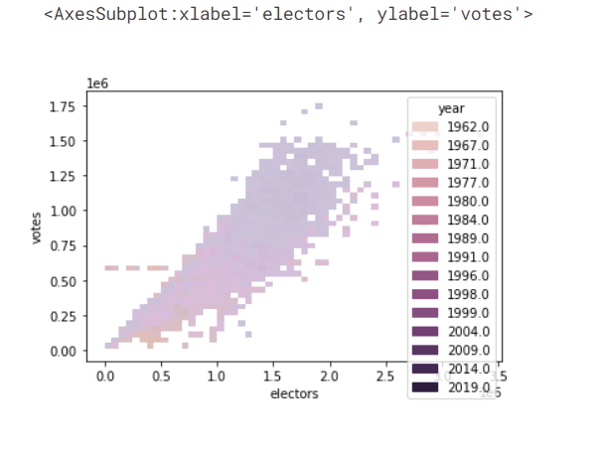

It forms as liner cluster of points

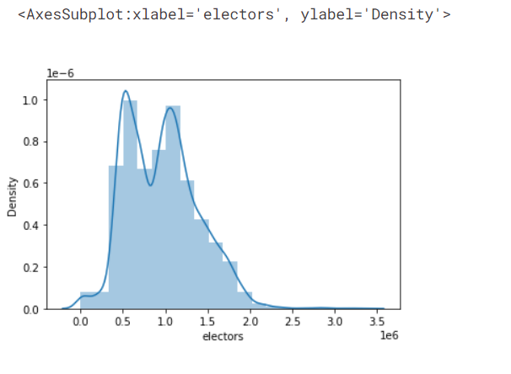

we can see the distribution is bi model and Having global maximum and two local maximum

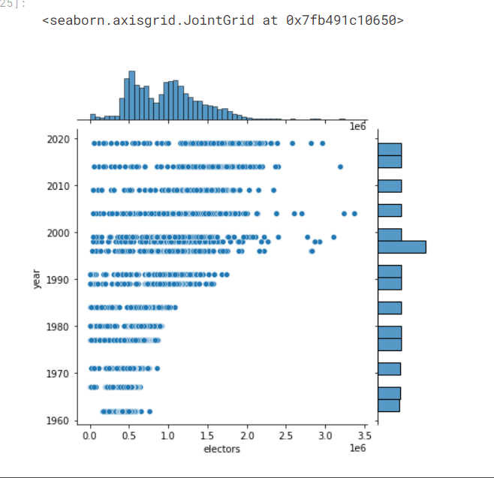

The overall electors vote graph forms a two bell curve which depicts it’s a bi model graph, having two peaks, but one global peak.

We can see that in 1990 to 2000's the electors are maximum.

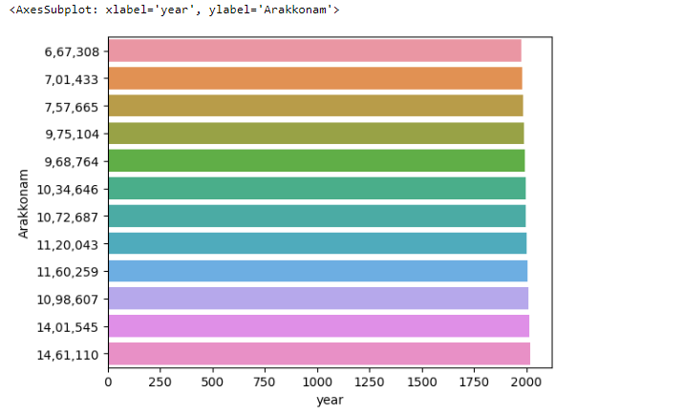

We can see in 2009 the eligibility of the person to vote got reduced more

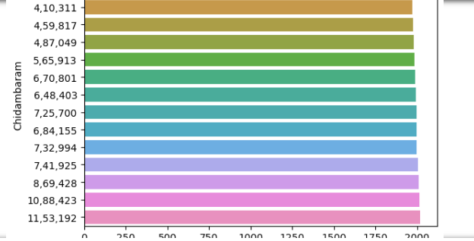

Similarly we can see the people voted for the different constituency

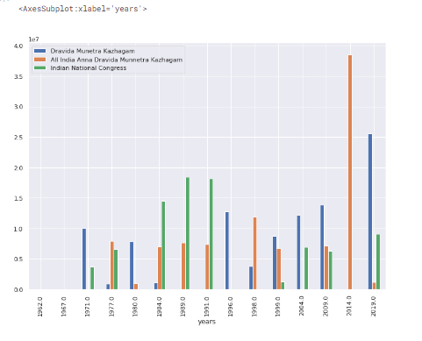

We can see in 2014 DMK lost Deposit and 2019 DMK constituency vote increased drastically and we can see the presence of congress in 1984, 1989 and 199

**MACHINE LEARNING AND DEEP LEARNING MODELS:**

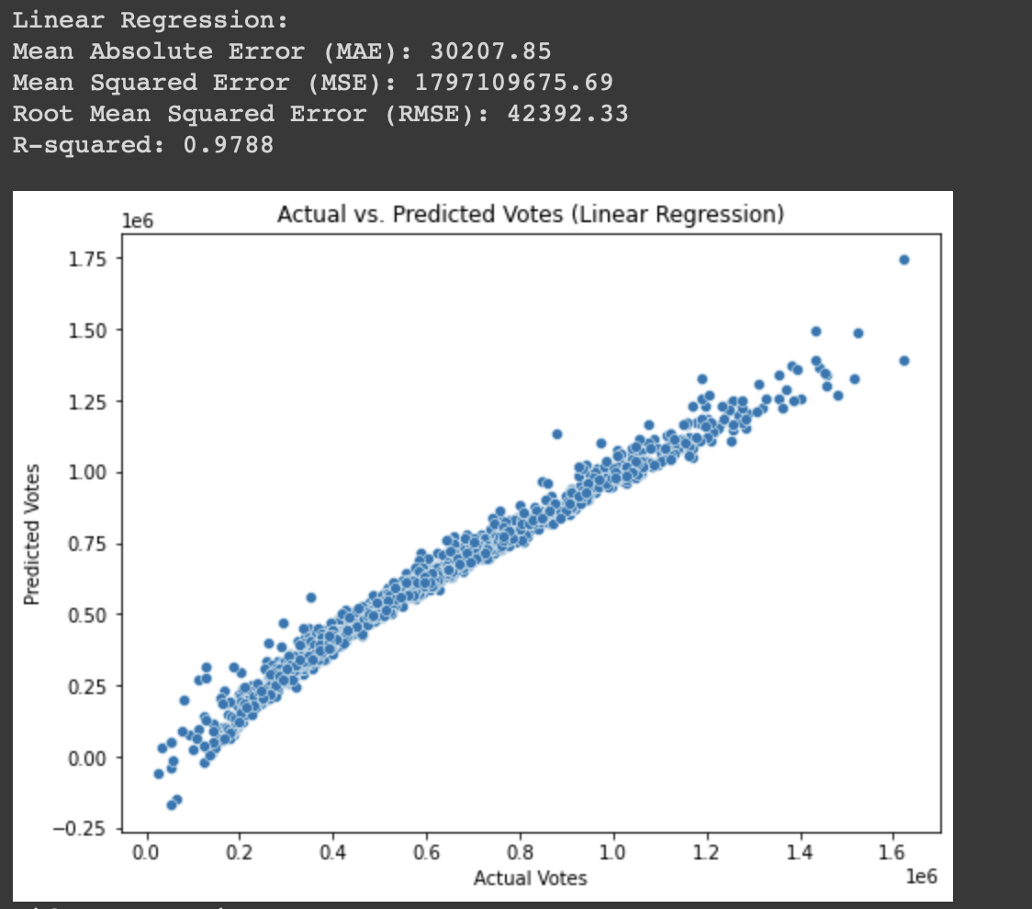

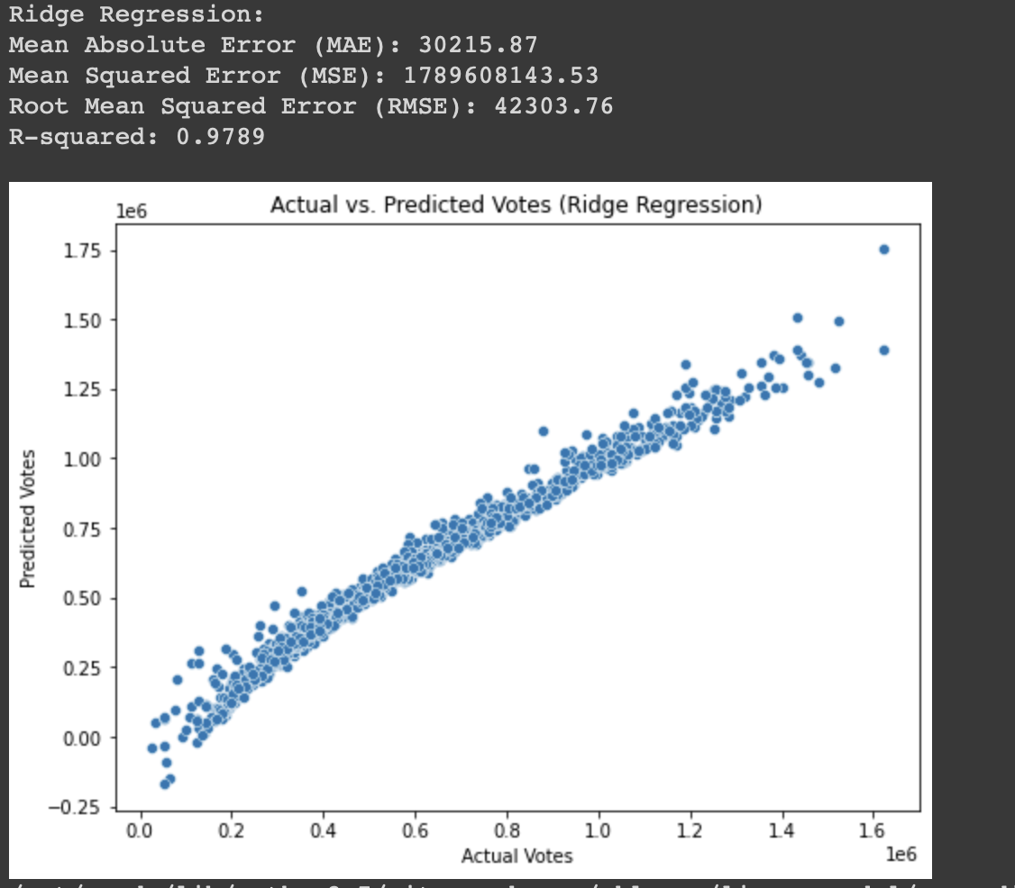

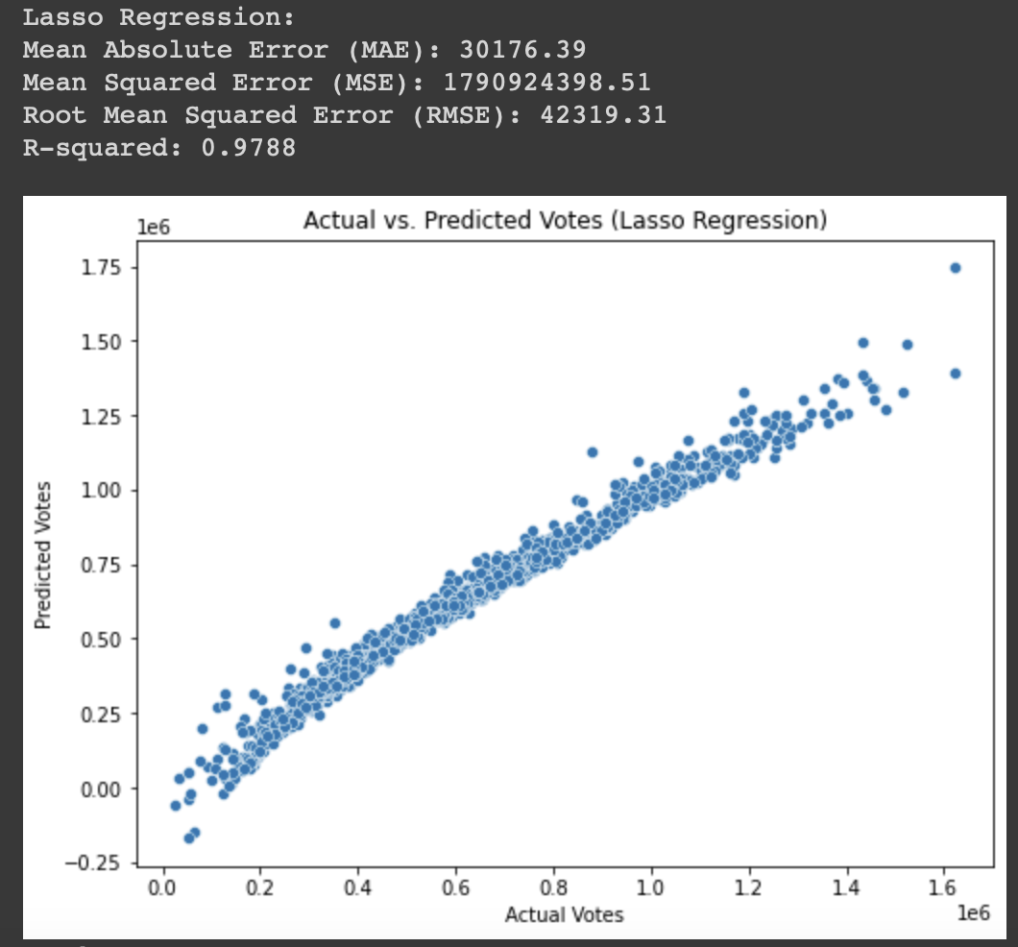

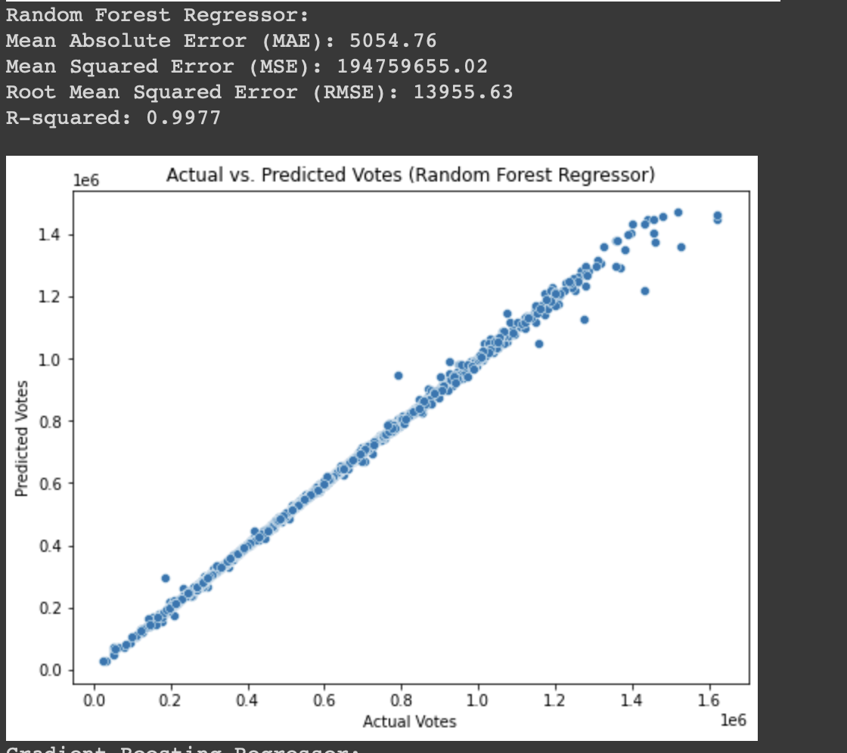

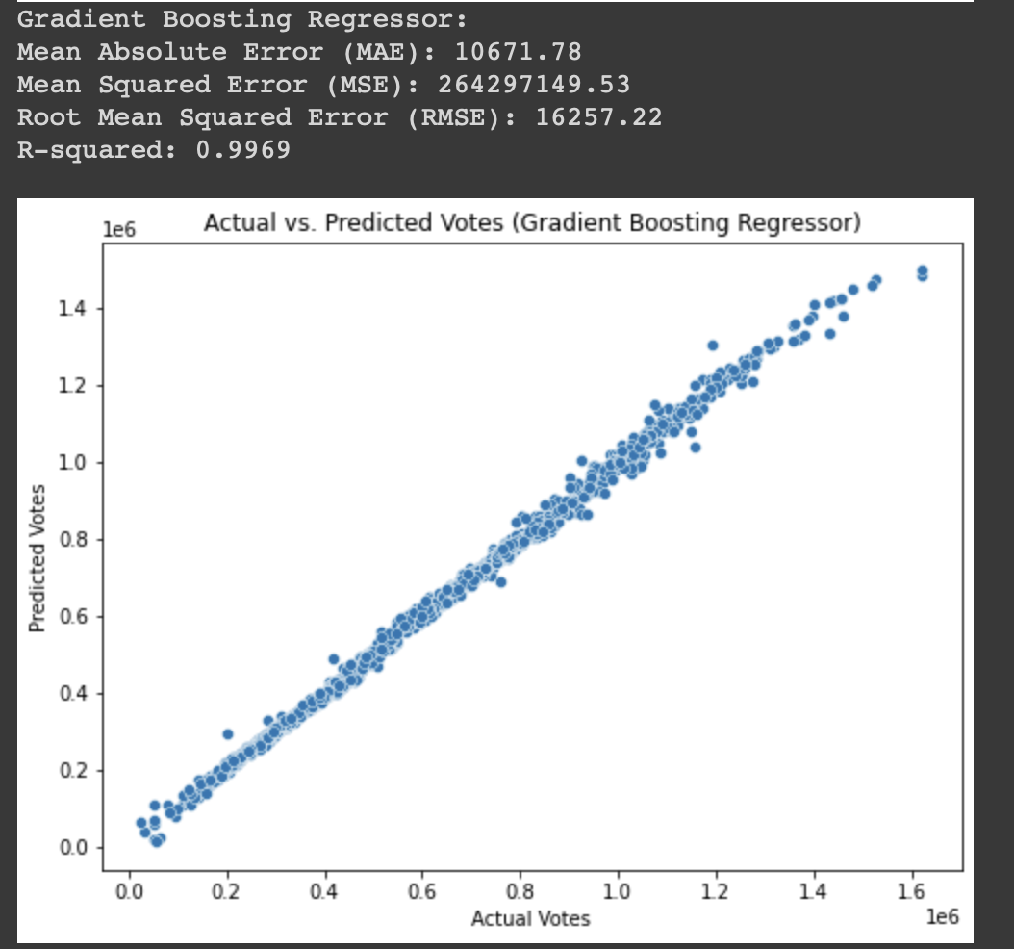

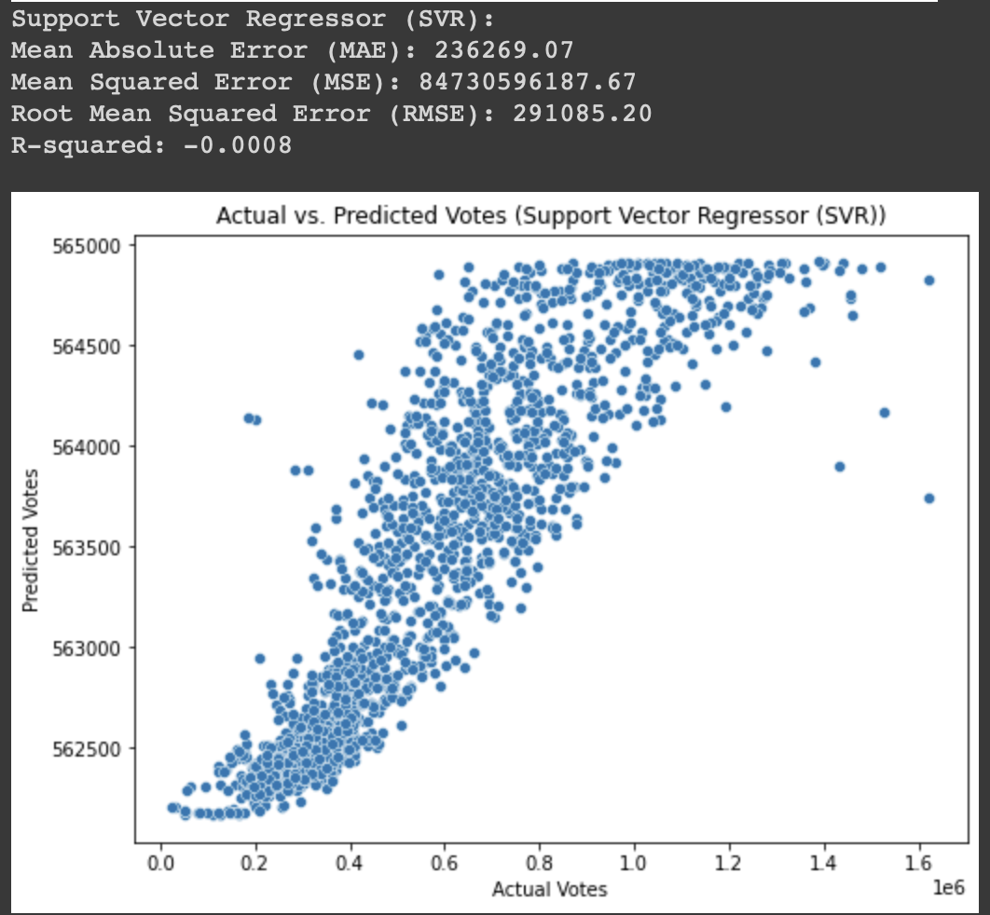

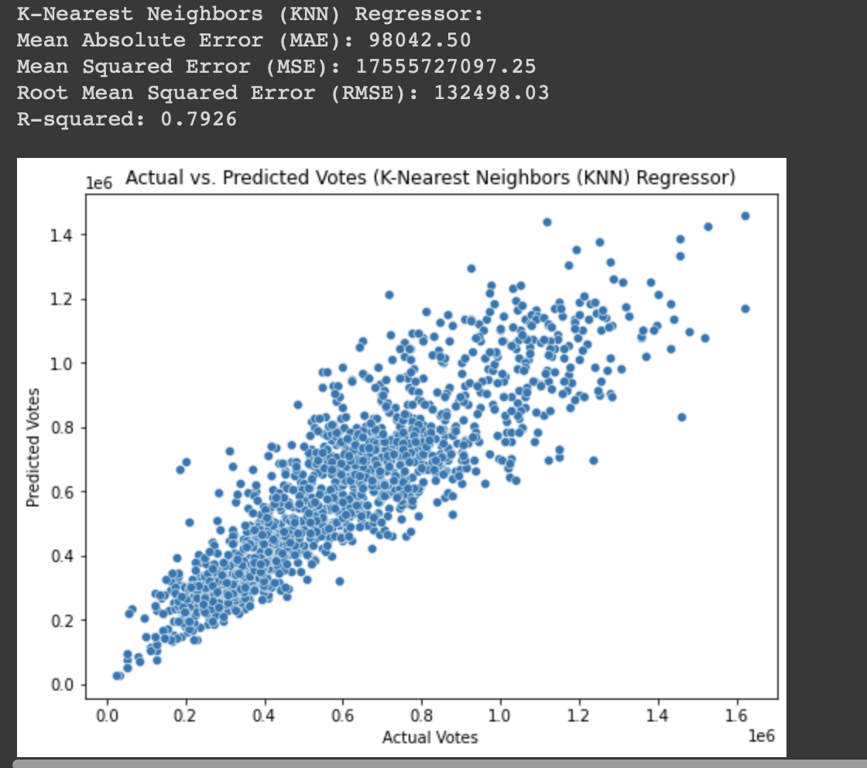

**RESULTS:**

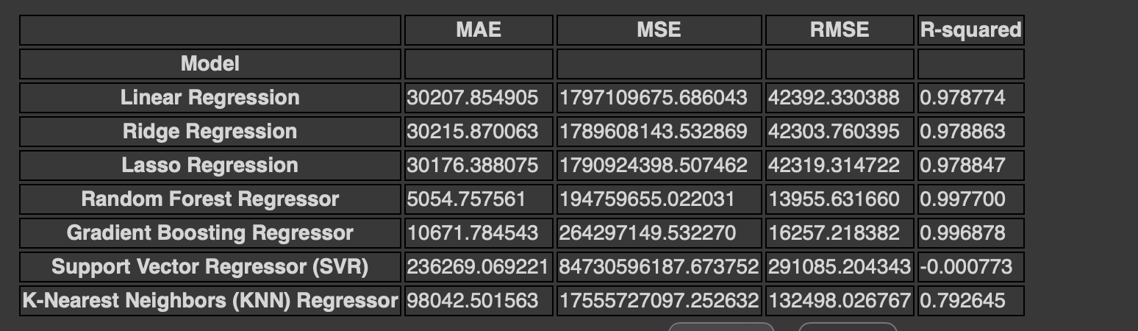

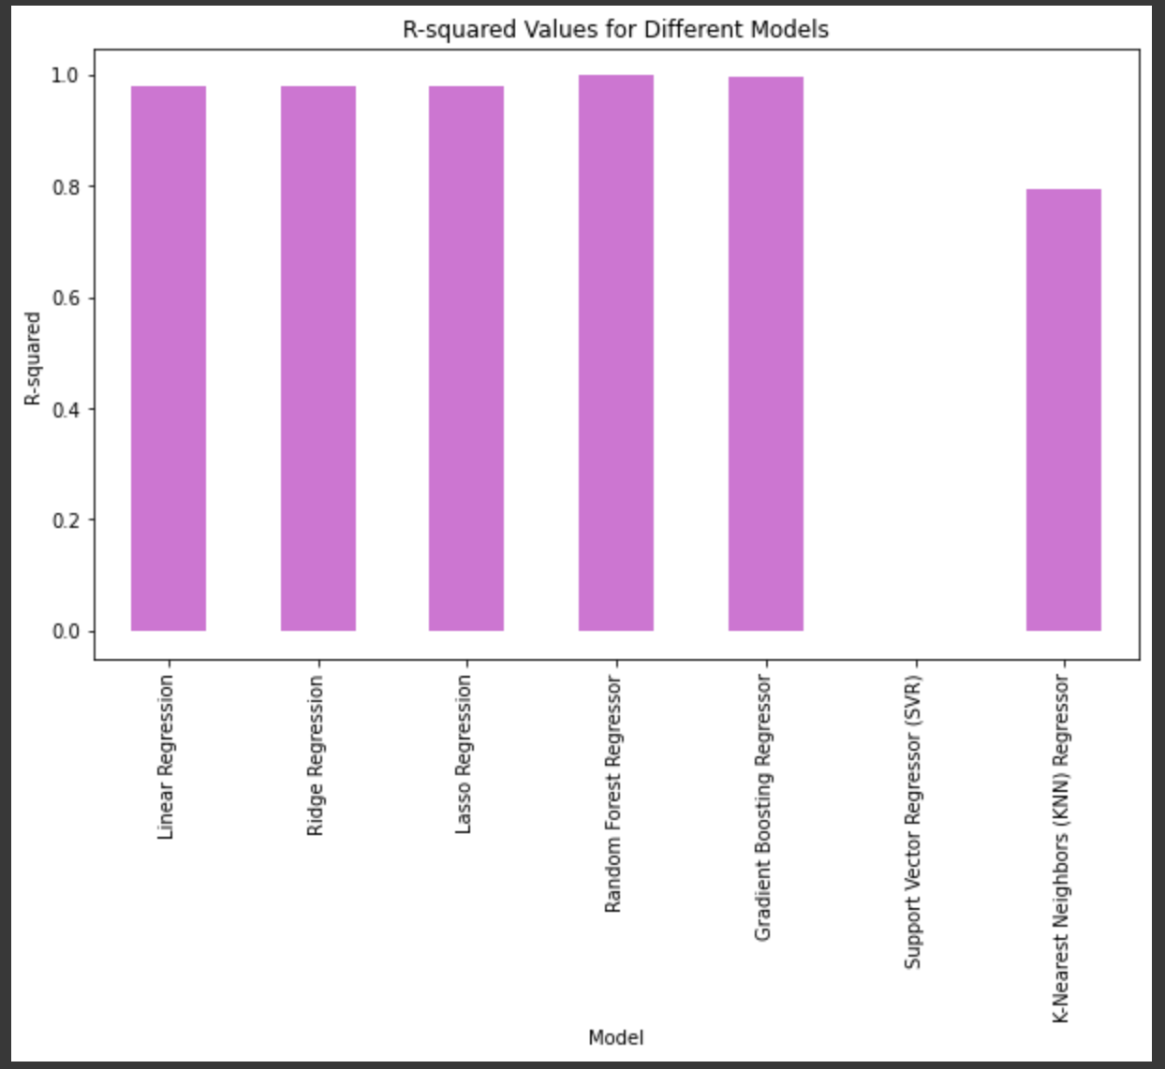

**Visualize party performance with time series plot:**

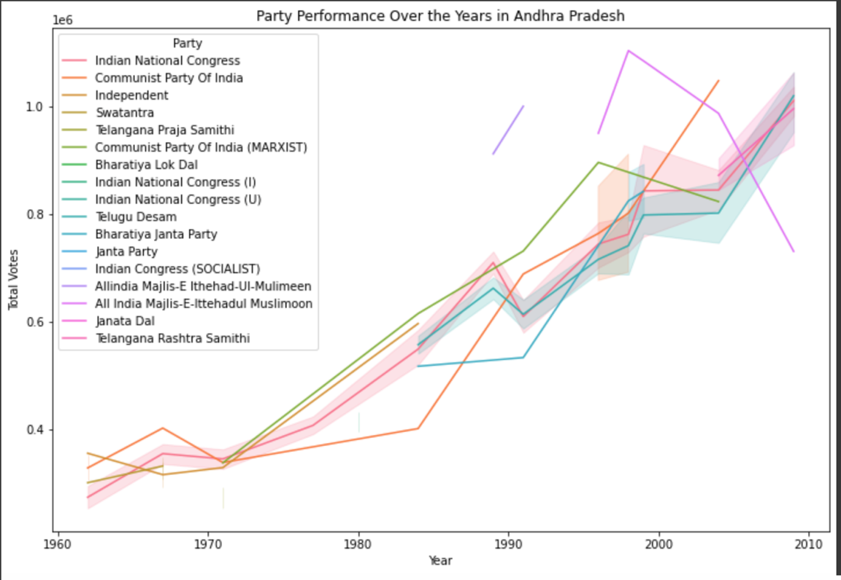

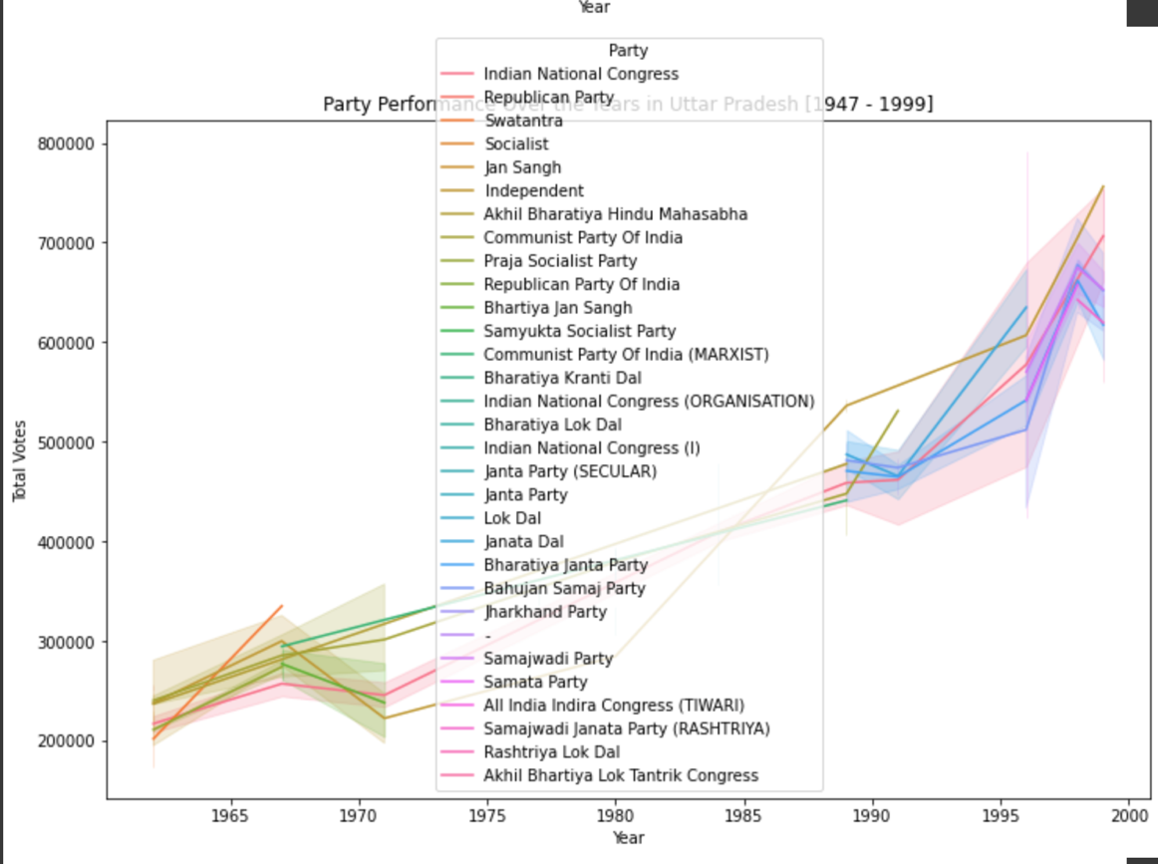

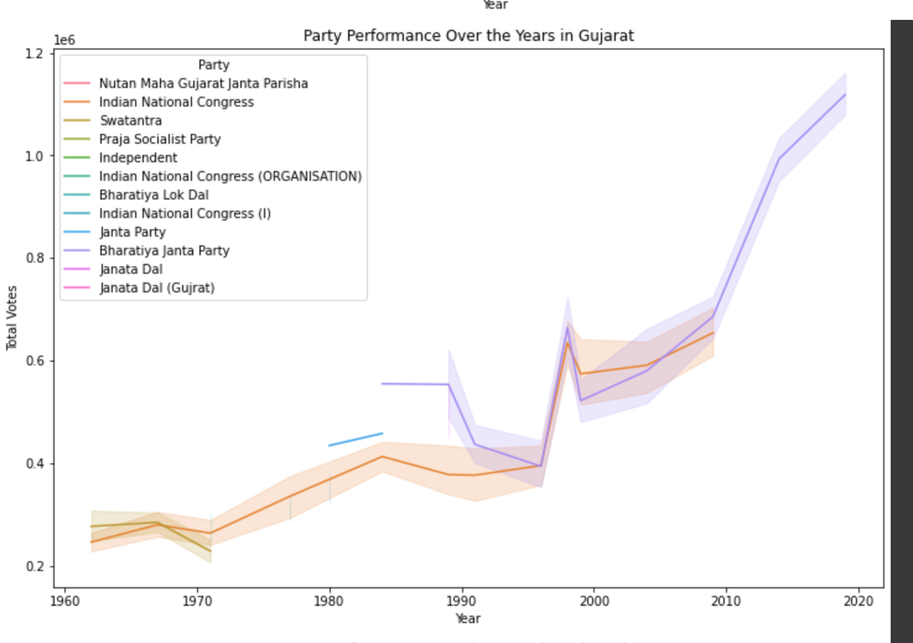

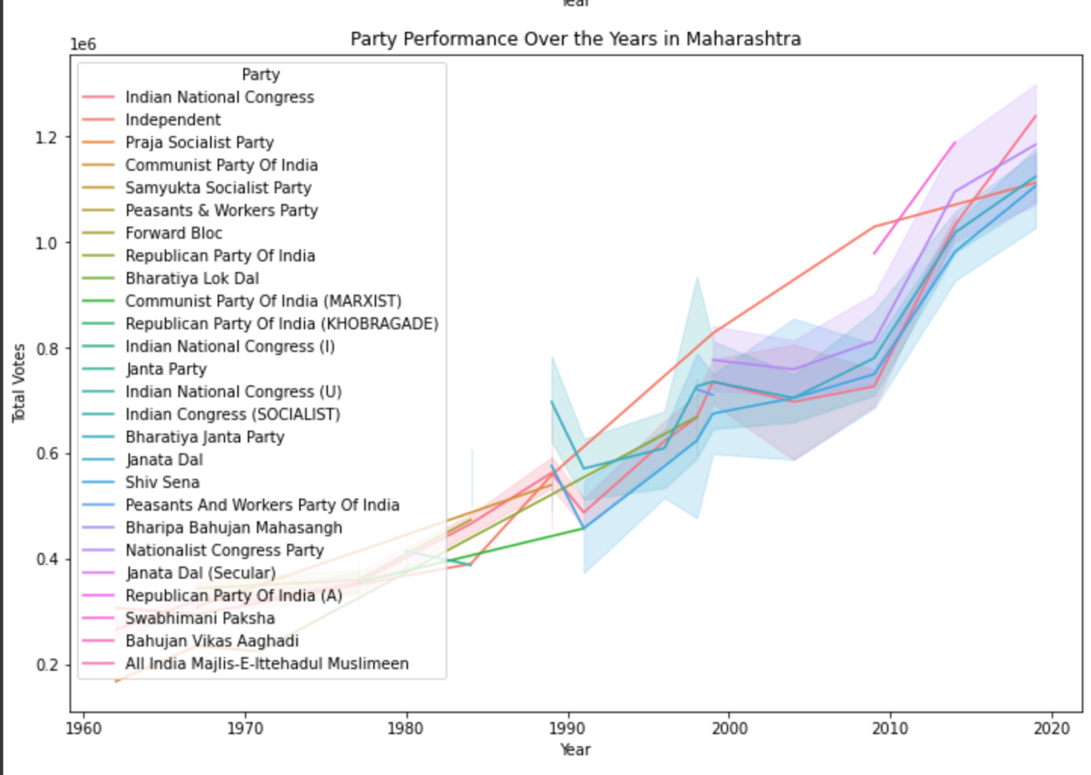

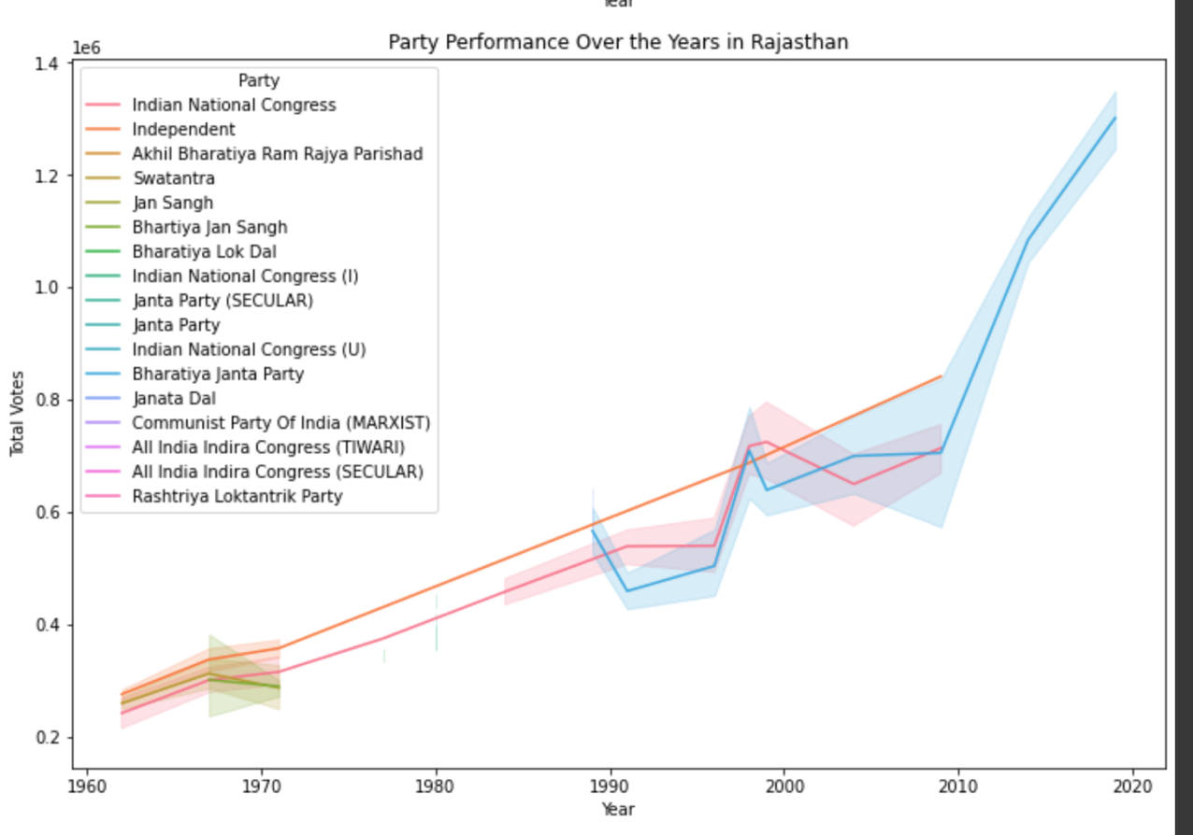

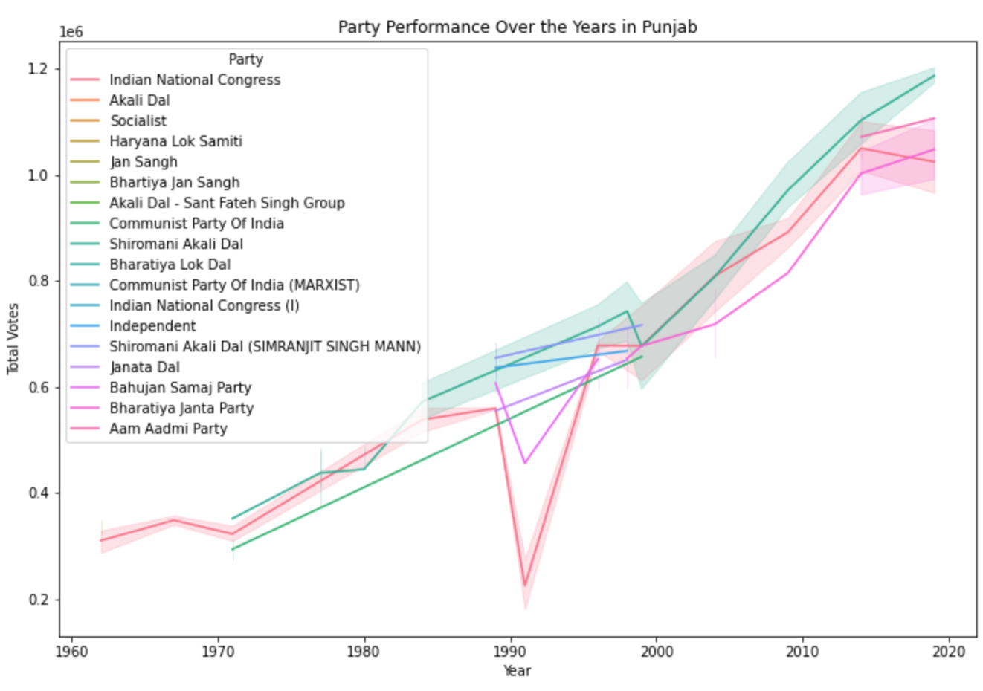

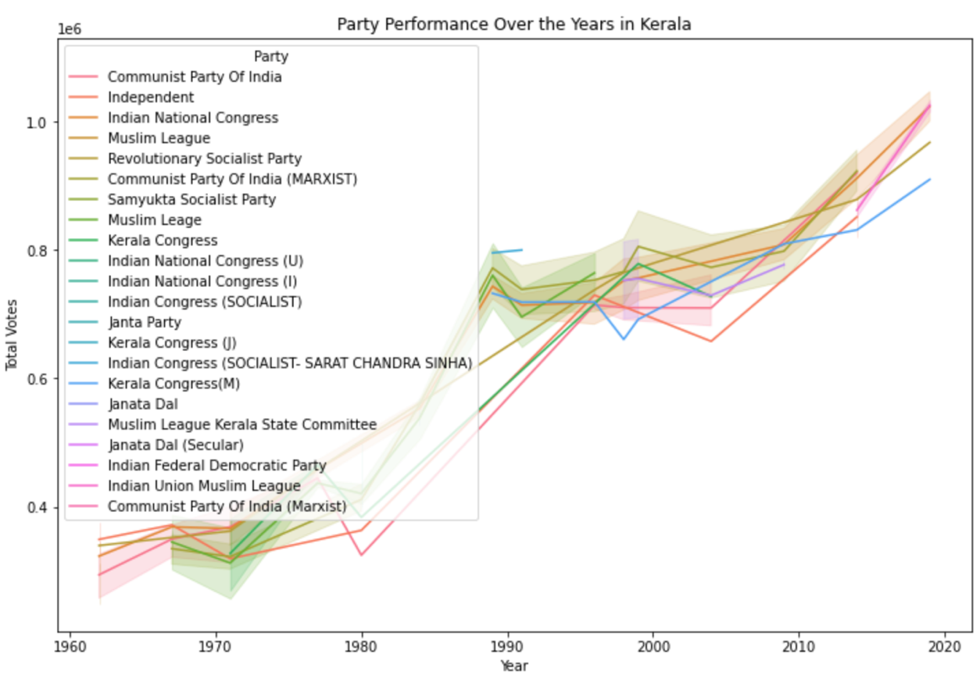

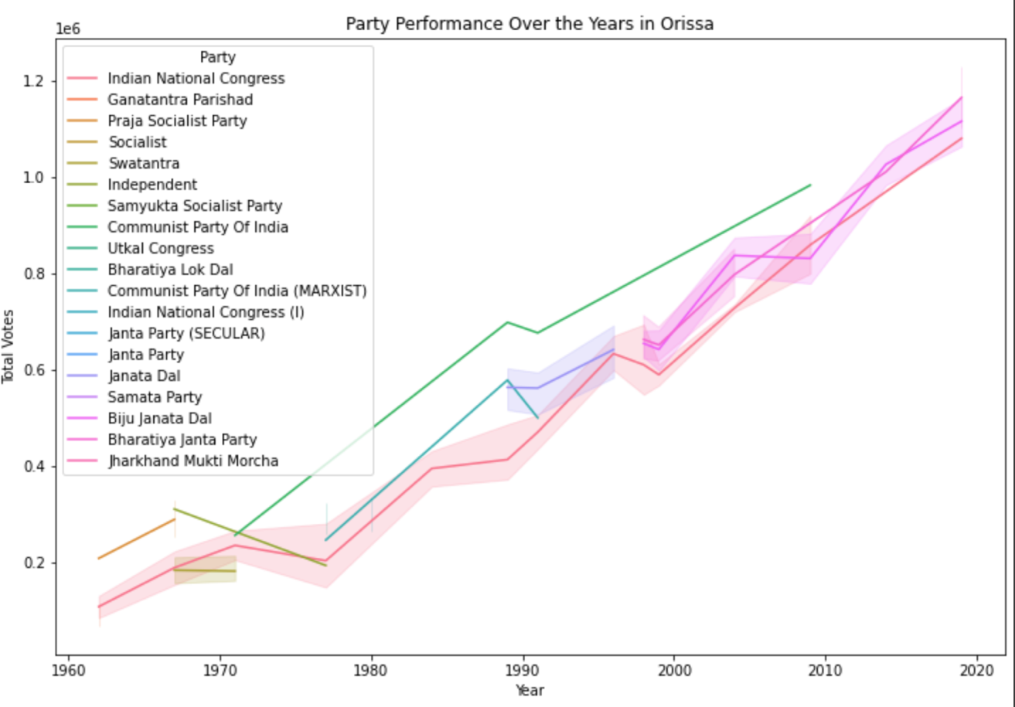

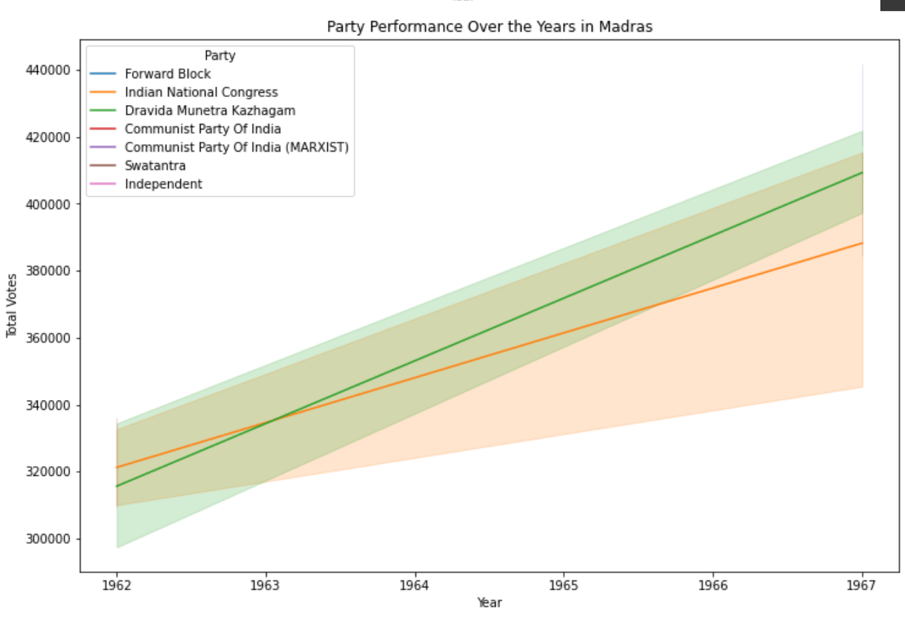

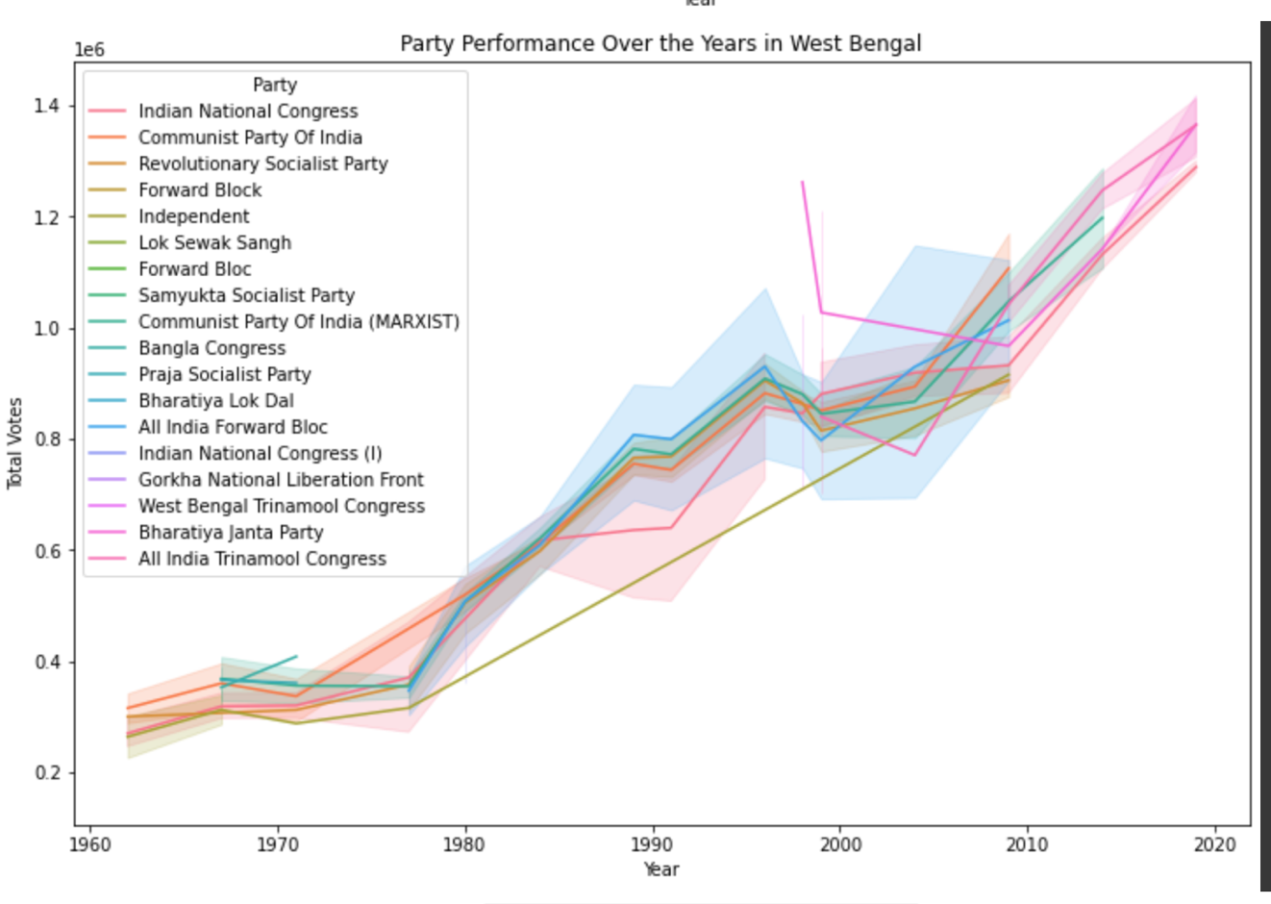

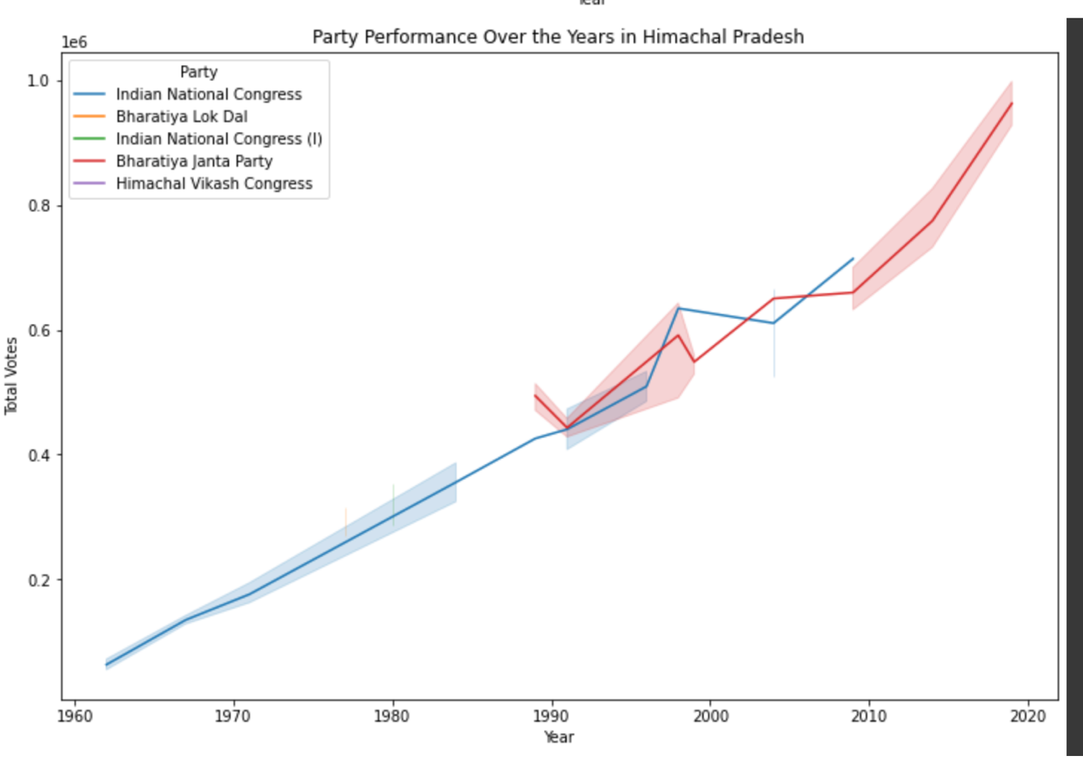

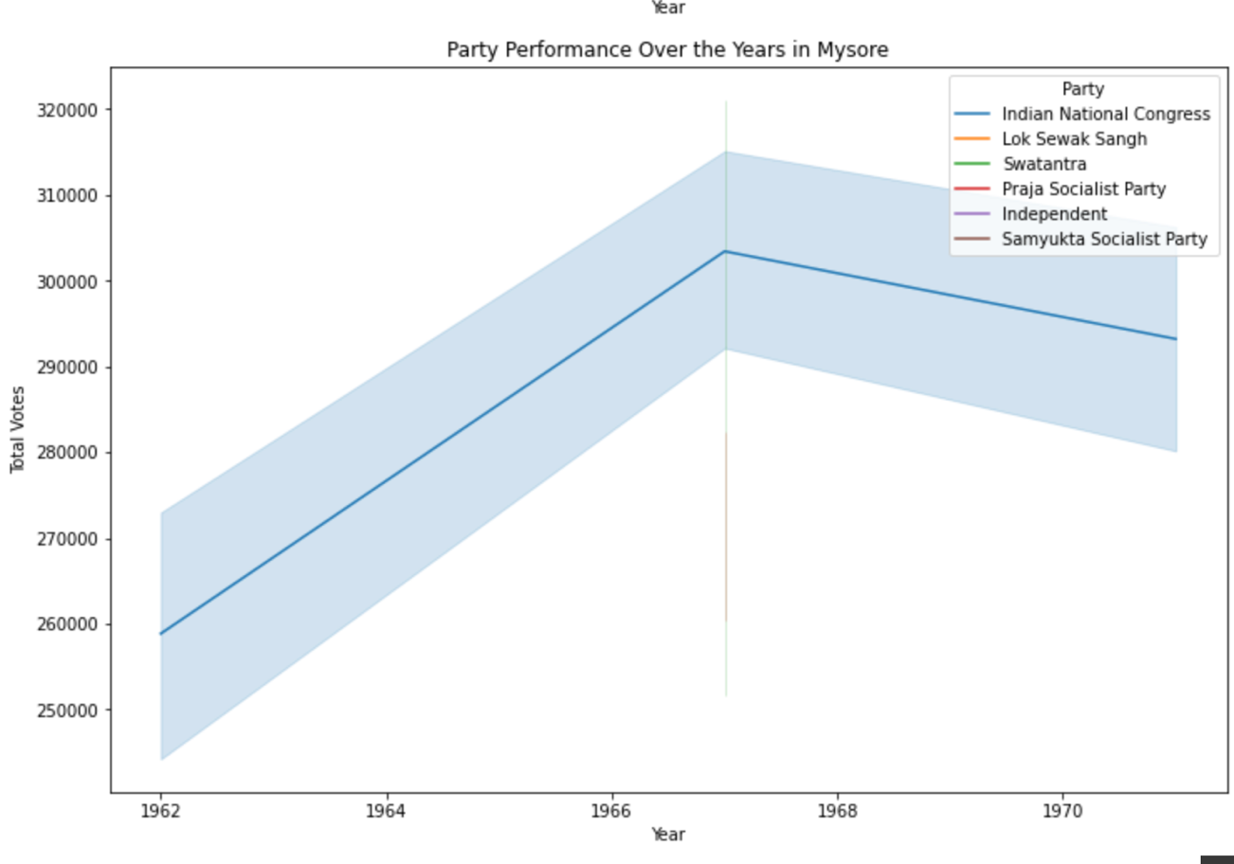

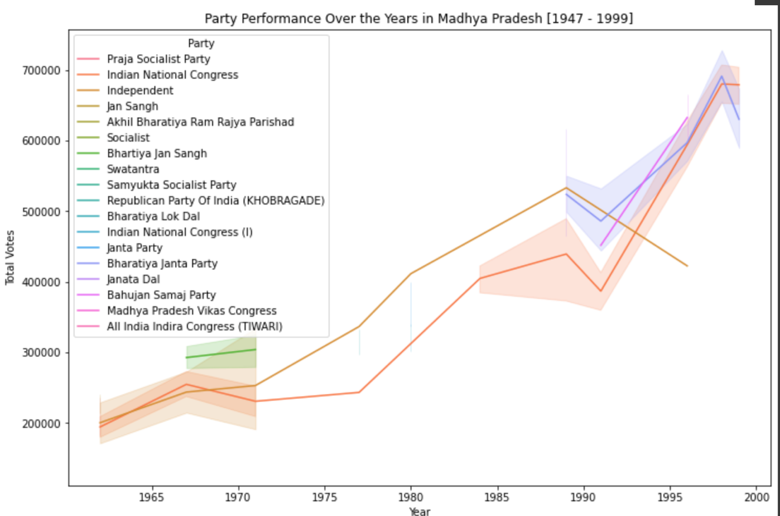

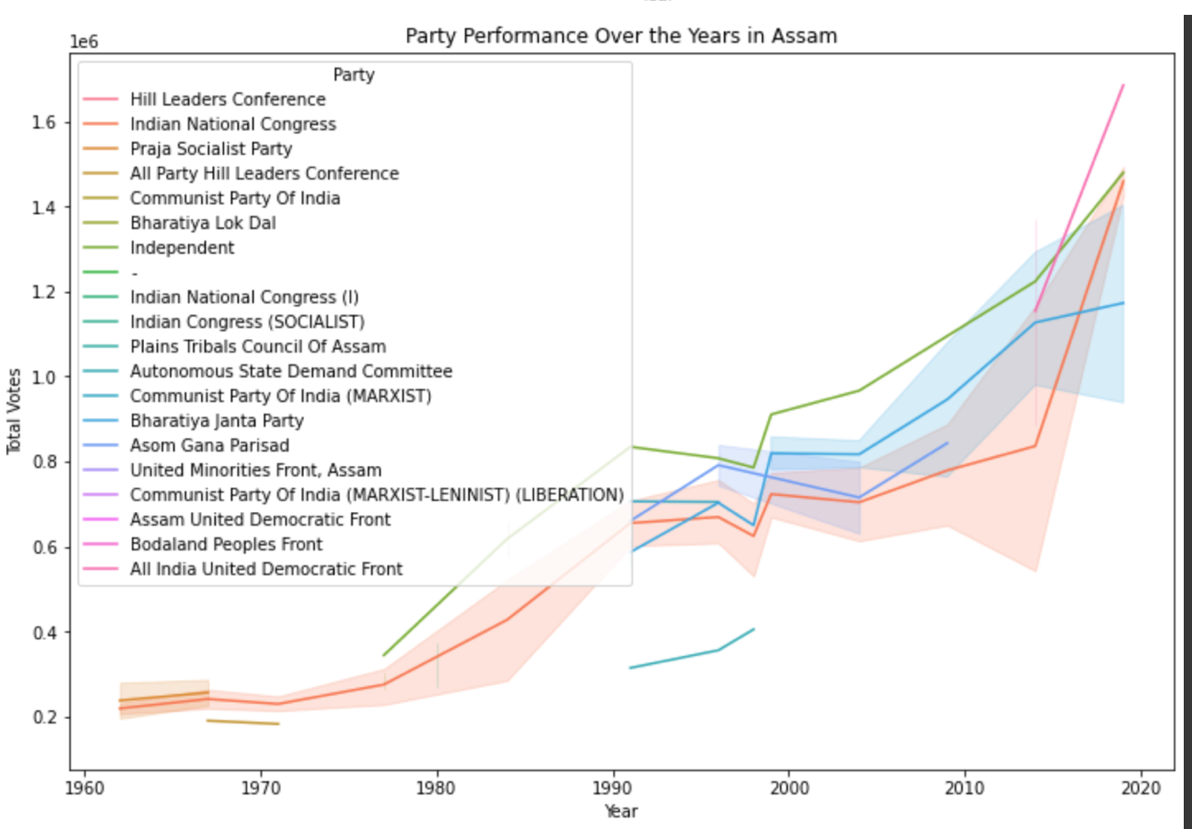

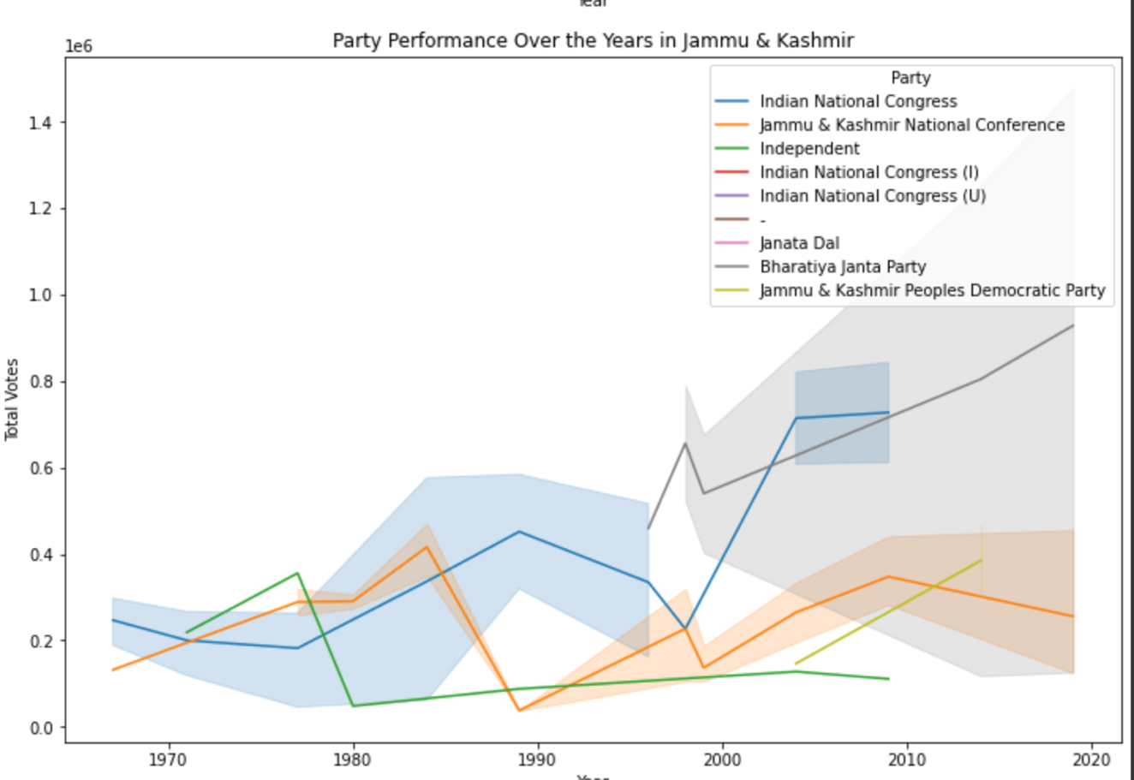

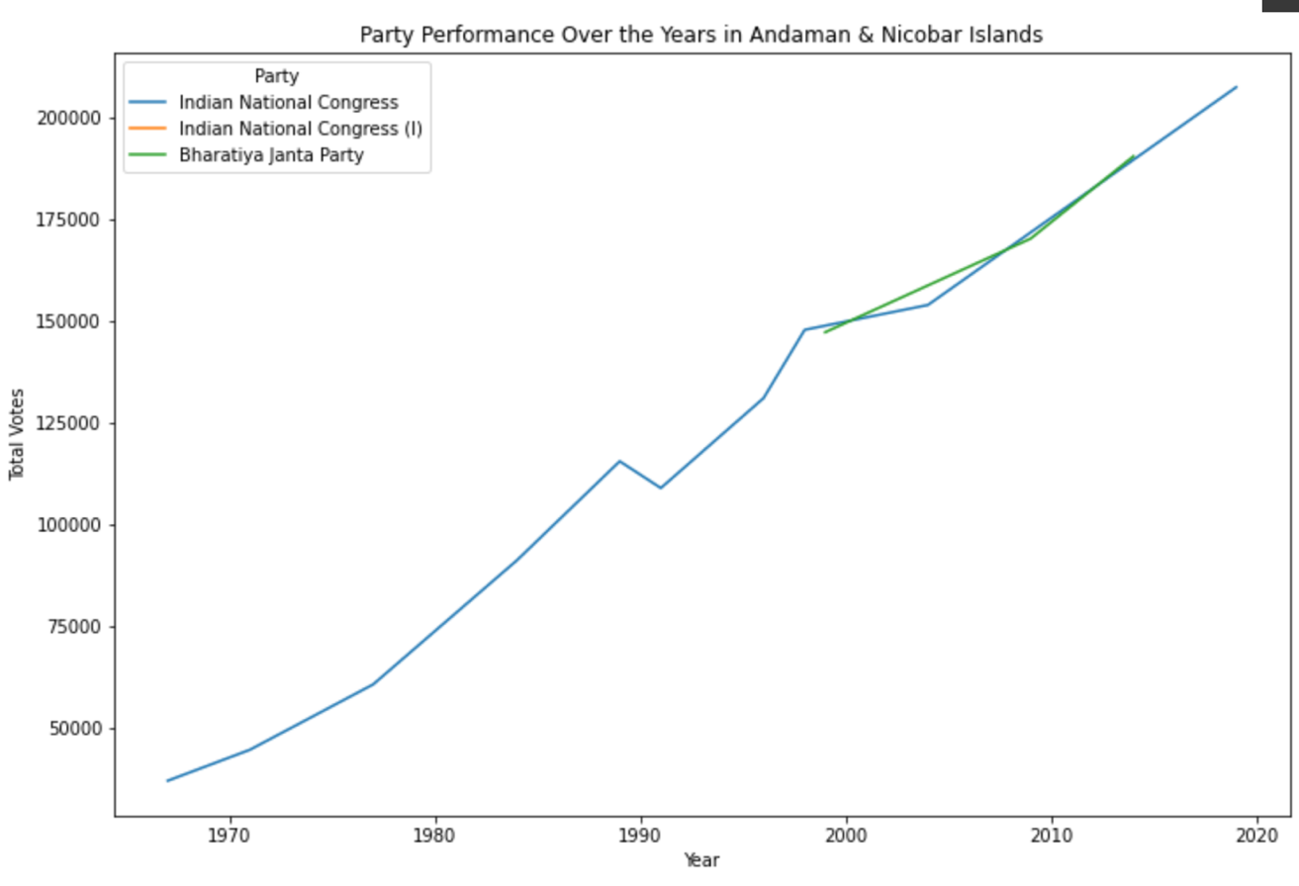

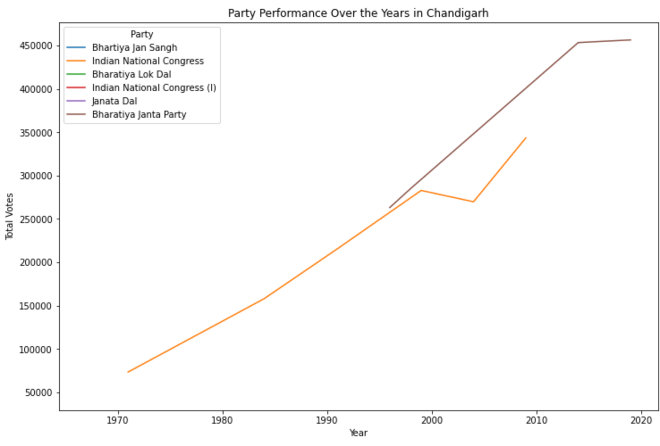

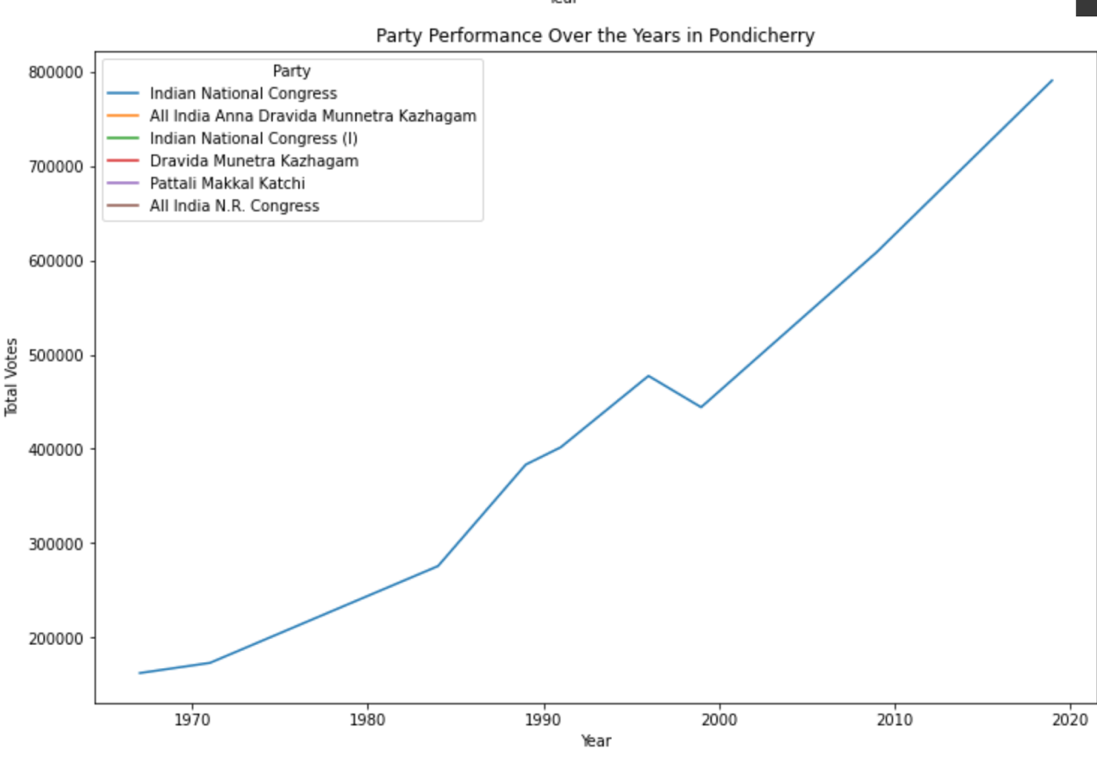

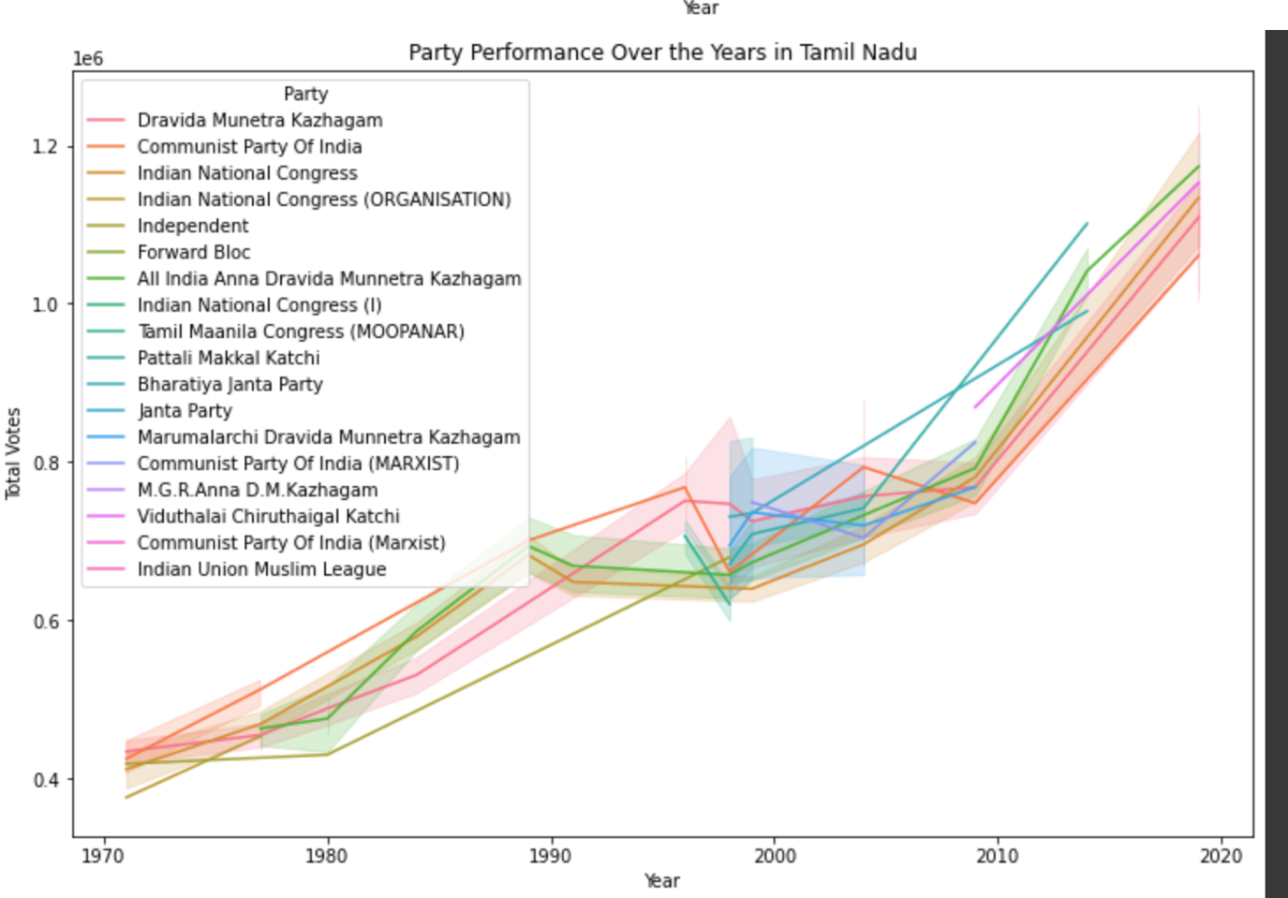

# 7.CONCLUSION

# The project finally provides an interactive visualization of the election dataset at the year 2014 since it was a year of major political shift for India with BJP coming into great dominance. It was observed that all major states except the states of deep south India like Tamil Nadu, Kerala and an exception which is west Bengal has a dominance of local parties but others are either divided in to congress or BJP.

# This project tries to represent the election dataset with many different visualization techniques with the help of machine learning and deep learning models for easy understanding of it for the viewers. This will help the sectors like news who does lot of visualization of electoral data to simplify it to the people of India.

**8.PROJECT CODE LINK:**

<https://colab.research.google.com/drive/1TeLblzfwdtfEYP2-UI5zJ0IxzKZ8bqaQ?usp=sharing>

**9.REFERENCES**

1. Jensenius, Francesca R., and Gilles Verniers. "Studying Indian politics with large-scale data: Indian election data 1961–today." *Studies in Indian Politics* 5.2 (2017): 269-275.
2. Kumar, Mohit, et al. "LokDhaba: Acquiring, Visualizing and Disseminating Data on Indian Elections." *Proceedings of the 3rd ACM SIGCAS Conference on Computing and Sustainable Societies*. 2020.
3. <https://blog.gramener.com/general-elections-india-data-visualizations>
4. <http://xenon.stanford.edu/~hangal/acmcompass2020-final93.pdf>
5. Gupta, Kuhu, et al. "Visualization of election data: Using interaction design and visual discovery for communicating complex insights." *JeDEM-eJournal of eDemocracy and Open Government* 8.2 (2016): 59-86.
6. Gao, Jun, and Peter Revesz. "Visualization of temporal-oriented datasets." *Geometric Modeling and Imaging--New Trends (GMAI'06)*. IEEE, 2006.
7. Yaqub, Ussama, et al. "Location-based sentiment analyses and visualization of Twitter election data." *Digital Government: Research and Practice* 1.2 (2020): 1-19.
8. <https://tcpd.ashoka.edu.in/lok-dhaba/>
9. <https://www.researchgate.net/publication/326164970_Visualization_of_election_data_Using_interaction_design_and_visual_discovery_for_communicating_complex_insights>
10. <https://analyticsindiamag.com/6-datasets-to-visualize-lok-sabha-election-by-numbers/>
11. <https://www.indiavotes.com/>
12. Jiang, Yazhen, Joseph D. Skufca, and Jie Sun. "BiFold visualization of bipartite datasets." *EPJ Data Science* 6.1 (2017): 1-19.